Nepal College of information Technology
Imado lalitpur
Assessment Exam Fall Semester 2006

Program : ELX Semester: V
Time : 3hrs Year : 2006
Engineering Math-I

1 a) Integrate the following:- (any three) 5*3=15
i 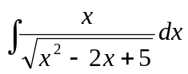 ii 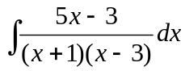
iii 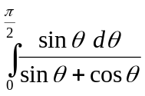 iv 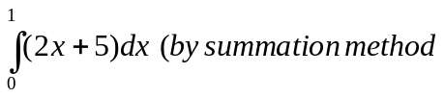
2. a) Find the area bounded by the curve y=x², the x=axis and the ordinates x=1 and x=3. 7
b) Find the volume of the solid generated by revolving the regious bounded by y=2x , y=x., x=1 about x-axis.
OR
Find the distance traveled between t=0 and t=π by the particle p(x,y) whose position at any time t is x=cost, y= t+ sint
3. a) Find the approximate area using Simpson's rule and Trapezoidal rule for the area bounded by the curve y= f(x) = (2x+1)² the x - axis and the lines x=1 and x=5 ( Using n =4) 8
b) Define scalor product and vector product of two vectors. If 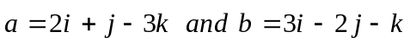 find their scalar product and vector product. 1+1+5
4. a) Find the equation for the plane through (2 ,4, 5) and perpendicular to the line 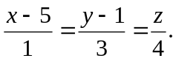 7
b) Let 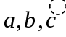be any three vectors, show that 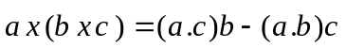 8
Or
Show that are coplanar.
5. a) Transform the equation x² + 2cxy + y² , by turning the rectangular axes through the angle 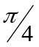 7
b) A double ordinate of the parabola y² = 2ax is of length 4a, prove that the lines joining the vertex to its ends are at right angles. 8
6. a) Find centre, vertices foci and eccentricity of the ellipse 25x² +9y² - 100x + 54y -44 = 0 8
b) Show that standard equation of hyperbola is 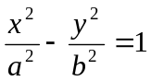 8
Or
Show that
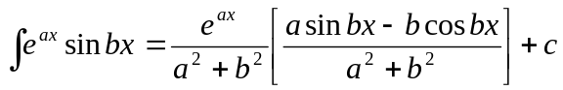
7. Attempt any four 2.5*4=10
i) Find the vector projection of
ii) 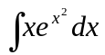
iii) Find equation of tangent (2, 1/4) on the parabola y² =16x.
iv) Find the volume of a paralleopiped whose concurrent edges are 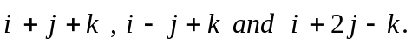
v) Sketch the hyperbola 